**MySQL安装配置**

开始制作日期：2010/8/5

制作日志：

|  |  |  |  |
| --- | --- | --- | --- |
| **版本** | **内容** | **文档编制人** | **编制日期** |
| V1.0 | MySql安装配置 | 时阳阳 | 2010/08/05 |
| V1.1 | 《小小忍者》数据库环境安装配置 | 赵发强 | 2010/10/16 |

Software involved：mysql-essential-5.1.48-winx64.msi、SQLYogEnterprise、DB scripts

Double –click mysql-essential-5.1.48-winx64.msi to install mysql  
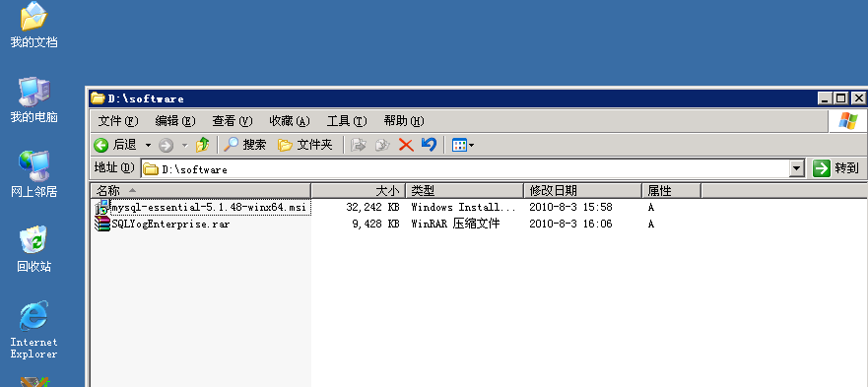

After you see msg below, click’ Next’

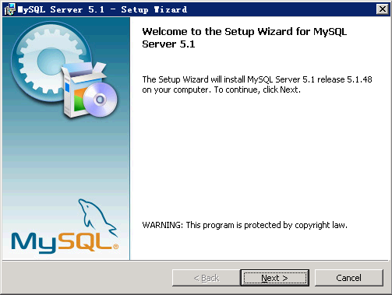

Choose ‘Custom’，click ‘Next’

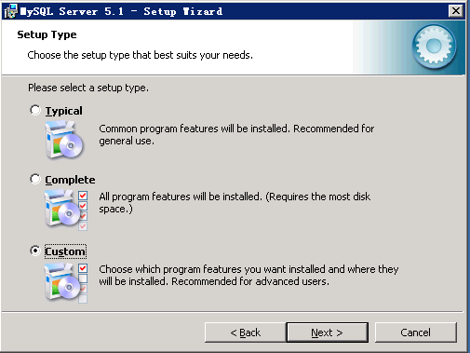

Select ‘MySQL Server’，click’Change’

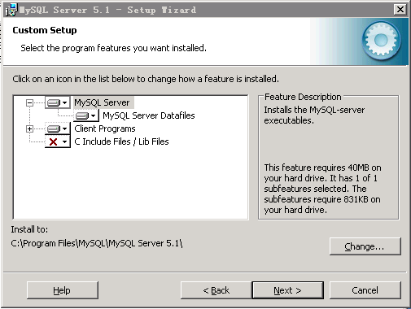

Modify your path：D:\MySQL Server 5.1，click ‘OK’

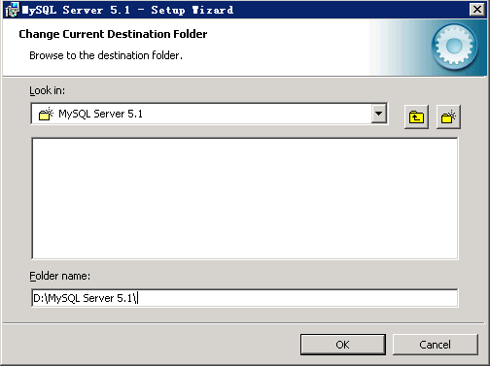

Select MySQL Server Datafiles，click ‘Change’

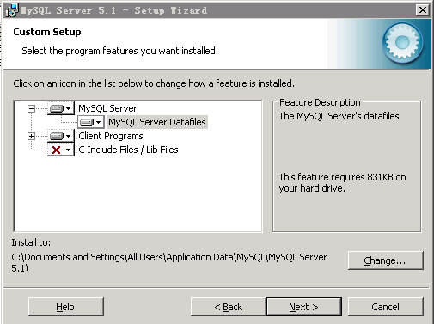

Modify path：D:\MySQL Server 5.1，click ‘OK’

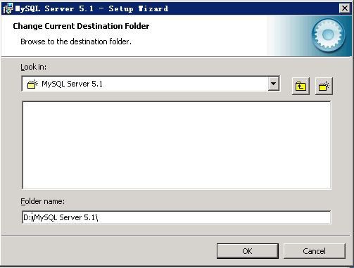

Click ‘Next’

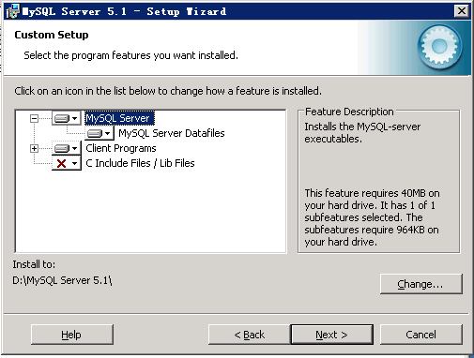

Click ‘Install’ to start install

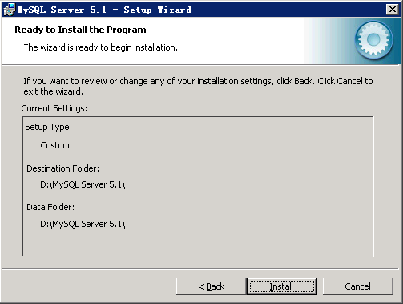

Wait until installation complete

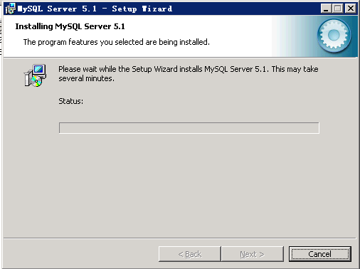

Click ‘Next’

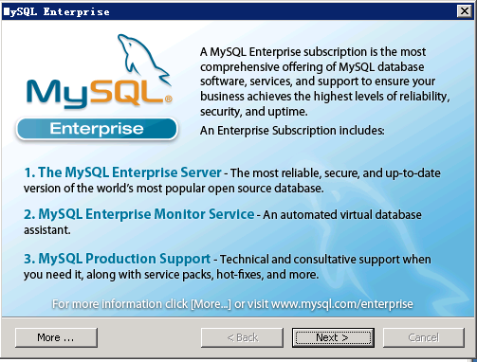

Click ‘Next’

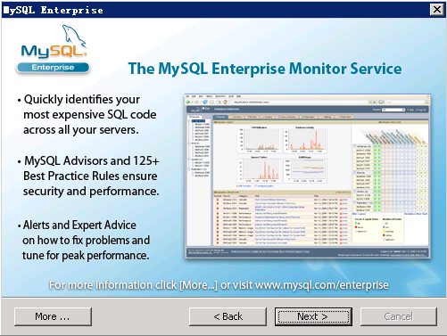

Click ‘Finish’

Now we can start to config Mysql Database：

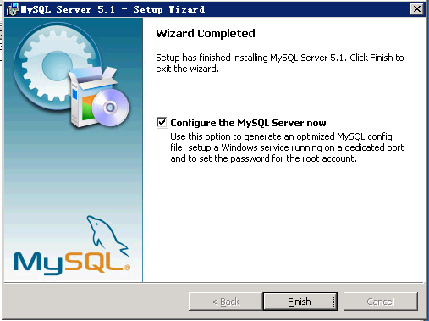

Click ‘Next’

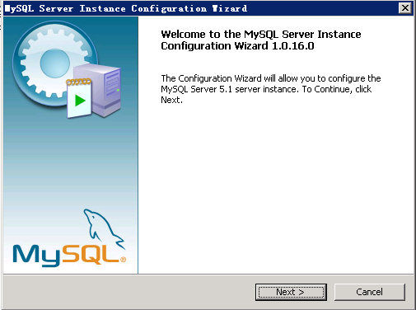

Slect Detailed Configuration，click Next

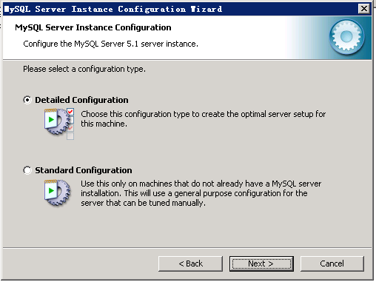

Slect Server Machine，click Next

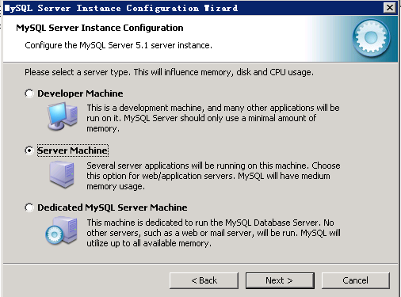

Select Multifunctional Database，click Next

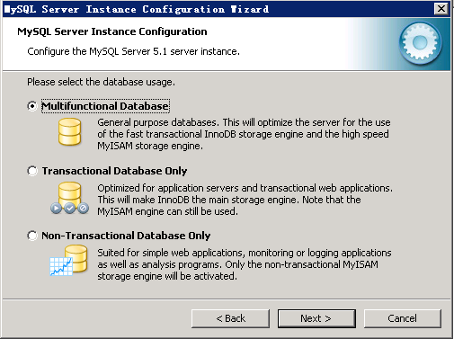

Click Next

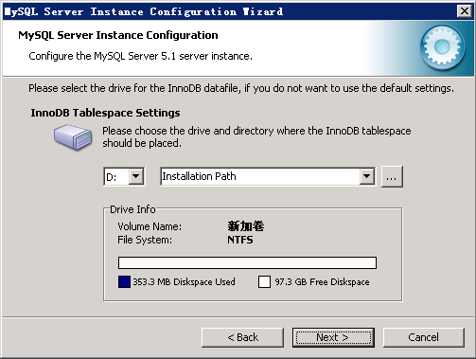

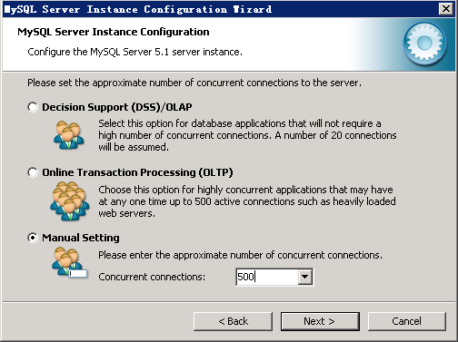

**Please note that you have to modify value of ‘Concyrrent connections’ to 1000, then click Next**

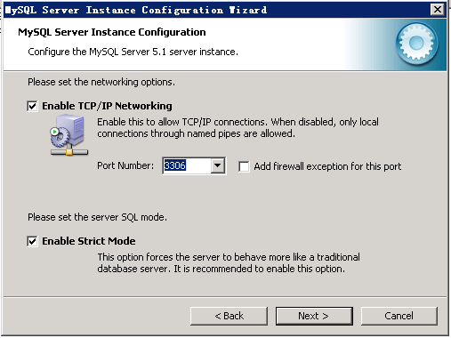

Select Manual Selected Default Character Set/Collation: utf8，Click Next

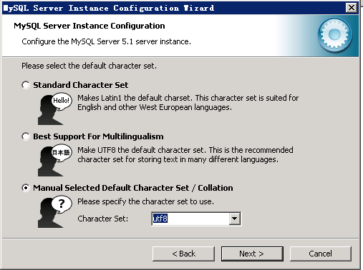

Set ‘Service Name’ as ’MySQL51’，and select ‘Include Bin Directory in Windows PATH’, click ‘Next’

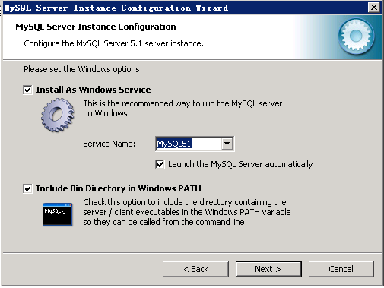

Set root password，select ‘Enable root access from remote machines’ click Next

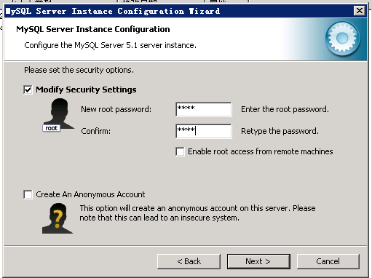

Click ‘Execute’

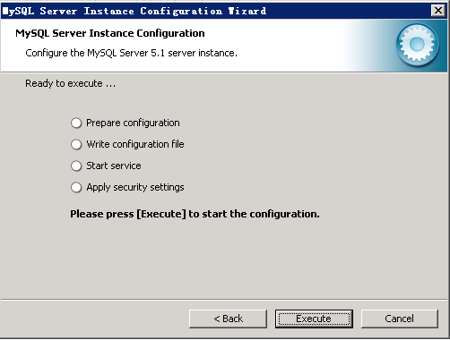

Click Finish，now configuration completed

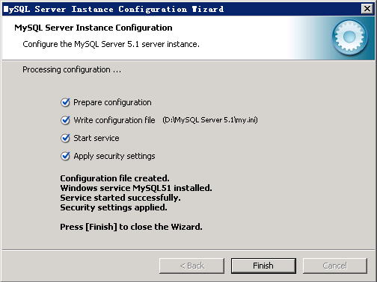

Modify parameters for mysql

Open folder：

D:\MySQL Server 5.1\my.ini

Find ‘ [mysqld]’ and modify 2 parameters below, if you can not find these 2 parameters, just add them:

max_allowed_packet = 4G

wait_timeout = 86400

innodb_file_per_table

restart mysql to active new parameters.

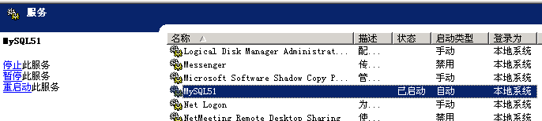

After that, you can start to install SQLYogEnterprise，and run DB scripts in SQLYogEnterprise